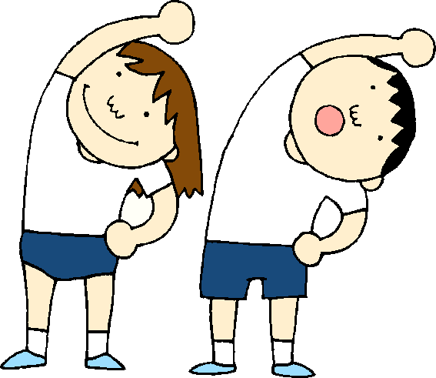

FIFTH GRADE
PHYSICAL EDUCATION UNITS

Physical Fitness Activities

Football

Soccer

Recreational and Creative Games

Cooperative Games

Volleyball

Floor Hockey

Basketball

Circus Arts

Low Organized Games

Adventure Education Games

Track and Field Activities

Field Day Activities

Softball

Lacrosse

